**Lab Assignment-1 Contents**

**Kanti**

**Gnanadeep**

**Usha**

**Program - 1**

**Readme**

1. Create a make file in the directory (Makefile.txt).

2. Use the command "make -f Makefile.txt".

3. Run the output file created from the "make" command.

4. ./<output file name in make file> <time-a.nist.gov/ip address>

5. Capture the output in ctime mode.

6. clean the output file using "make -f Makefile clean".

7. example : ./Daytime time-a.nist.gov

**Makefile**

all:

gcc -o Daytime UDPDaytime.c

clean:

rm -f Daytime

**Source code**

**UDPDaytime client program**

/* UDPDaytime.c - main

Group-02 Assignment-01

Make file, Output file included

*/

#define __USE_BSD 1

#include <stdarg.h>

#include <errno.h>

#include <netinet/in.h>

#include <time.h>

#include <arpa/inet.h>

#include <netdb.h>

#include <sys/socket.h>

#include <sys/types.h>

#include <unistd.h>

#include <stdlib.h>

#include <string.h>

#include <stdio.h>

#define BUFSIZE 64

#define UNIXEPOCH 2208988800 /* UNIX epoch, in UCT secs : Number of seconds from1st January 1900 */

#define MSG "what time is it?\n"

#ifndef INADDR_NONE

#define INADDR_NONE 0xffffffff

#endif

extern int errno;

typedef unsigned short u_short;

extern int errno;

int errexit(const char *format, ...);

typedef unsigned long u_long;

extern int errno;

/*connectUDP - connect to a specified TCP service on a specified host */

/*

* Arguments:

* host - name of host to which connection is desired

* service - service associated with the desired port

*/

int connectsock(const char *host, const char *service, const char *transport);

int connectUDP(const char *host, const char *service);

int errexit(const char *format, ...);

/*------------------------------------------------------------------------

* main - UDP client for TIME service that prints the resulting time

*------------------------------------------------------------------------

*/

int main(int argc, char *argv[])

{

char *host = "localhost"; /* host to use if none supplied */

char *service = "time"; /* default service name */

time_t now; /* 32-bit integer to hold time */

int s, n; /* socket descriptor, read count*/

switch (argc)

{

case 1:

host = "localhost";

break;

case 3:

service = argv[2];

case 2:

host = argv[1];

break;

default:

fprintf(stderr, "usage: UDPtime [host [port]]\n");

exit(1);

}

s = connectUDP(host, service);

(void) write(s, MSG, strlen(MSG));

/* Read the time */

n = read(s, (char *)&now, sizeof(now));

if (n < 0)

errexit("read failed: %s\n", strerror(errno));

now = ntohl((u_long)now); /* put in host byte order */

now -= UNIXEPOCH; /* convert UCT to UNIX epoch */

printf("%s", ctime(&now));

exit(0);

}

/*------------------------------------------------------------------------

* connectsock - allocate & connect a socket using TCP or UDP

*------------------------------------------------------------------------

*/

int connectsock(const char *host, const char *service, const char *transport )

/*

* Arguments:

* host - name of host to which connection is desired

* service - service associated with the desired port

* transport- name of transport protocol to use ("tcp" or "udp")

*/

{

struct hostent *phe; /* pointer to host information entry */

struct servent *pse; /* pointer to service information entry */

struct protoent *ppe; /* pointer to protocol information entry*/

struct sockaddr_in sin; /* an Internet endpoint address */

int s, type; /* socket descriptor and socket type */

memset(&sin, 0, sizeof(sin));

sin.sin_family = AF_INET;

/* Map service name to port number */

if ( pse = getservbyname(service, transport))

sin.sin_port = pse->s_port;

else if ( (sin.sin_port = htons((u_short)atoi(service))) == 0 )

errexit("can't get \"%s\" service entry\n", service);

/* Map host name to IP address, allowing for dotted decimal */

if ( phe = gethostbyname(host) )

memcpy(&sin.sin_addr, phe->h_addr, phe->h_length);

else if ( (sin.sin_addr.s_addr = inet_addr(host)) == INADDR_NONE )

errexit("can't get \"%s\" host entry\n", host);

/* Map transport protocol name to protocol number */

if ( (ppe = getprotobyname(transport)) == 0)

errexit("can't get \"%s\" protocol entry\n", transport);

/* Use protocol to choose a socket type */

if (strcmp(transport, "udp") == 0)

type = SOCK_DGRAM;

else

type = SOCK_STREAM;

/* Allocate a socket */

s = socket(PF_INET, type, ppe->p_proto);

if (s < 0)

errexit("can't create socket: %s\n", strerror(errno));

/* Connect the socket */

if (connect(s, (struct sockaddr *)&sin, sizeof(sin)) < 0)

errexit("can't connect to %s.%s: %s\n", host, service,strerror(errno));

return s;

}

int connectUDP(const char *host, const char *service )

/*

* Arguments:

* host - name of host to which connection is desired

* service - service associated with the desired port

*/

{

return connectsock(host, service, "udp");

}

/*------------------------------------------------------------------------

* errexit - print an error message and exit

*------------------------------------------------------------------------

*/

/*VARARGS1*/

int errexit(const char *format, ...)

{

va_list args;

va_start(args, format);

vfprintf(stderr, format, args);

va_end(args);

exit(1);

}

**Program - 2**

**Readme**

1. To Open the editor:

gedit client.c

2. To Compile to program

gcc client.c -o client

3. To Execute the program

./client time-c.nist.gov time-d.nist.gov

**Makefile**

.PHONY: client

all: client

client:

gcc client.c -o client

clean:

rm client

**Source code**

TCP client program

/*

TCP Client program by group-02

Make file, code, output are provided

Reference: Internetworking with TCP/IP Vol. 3, Client-Server programming and applications, Comer and Stevens, Linux/POSIX Sockets version, ISBN: 0-13-032071-4, 2001.

*/

#include <errno.h>

#include <netinet/in.h>

#include <time.h>

#include <unistd.h>

#include <stdarg.h>

#include <stdio.h>

#include <stdlib.h>

#define __USE_BSD 1

#include <sys/types.h>

#include <sys/socket.h>

#include <netinet/in.h>

#include <arpa/inet.h>

#include <netdb.h>

#include <string.h>

#include <stdlib.h>

#ifndef INADDR_NONE

#define INADDR_NONE 0xffffffff

#endif /* INADDR_NONE */

/* TCPdaytime.c - TCPdaytime, main */

#include <unistd.h>

typedef unsigned short u_short;

extern int errno;

extern int errno;

#define LINELEN 128

int TCPdaytime(const char *host, const char *service);

int errexit(const char *format, ...);

int connectTCP(const char *host, const char *service);

int errexit(const char *format, ...);

/* connectTCP.c - connectTCP */

int connectsock(const char *host, const char *service,const char *transport);

//main - TCP client for DAYTIME service

int main(int argc, char *argv[])

{

char *host1 = "localhost"; /* host to use if none supplied */

char *host2 = "localhost"; /* host to use if none supplied */

char *service = "daytime"; /* default service port*/

switch (argc) {

case 1:

host1 = "localhost";

host2 = "localhost";

break;

case 4:

service = argv[3];

/* FALL THROUGH */

case 3:

host1 = argv[1];

host2 = argv[2];

break;

default:

fprintf(stderr, "usage: TCPdaytime [host [port]]\n");

exit(1);

}

int s1=TCPdaytime(host1, service);

int s2=TCPdaytime(host2, service);

printf("%d seconds is the difference between both the Time's",s2-s1);

exit(0);

}

/* TCPdaytime - invoke Daytime on specified host and print results*/

int TCPdaytime(const char *host, const char *service)

{

char buf[LINELEN+1];

int s, n,a,b,c,sum;

/* buffer for one line of text socket, read count*/

s = connectTCP(host, service);

while( (n = read(s, buf, LINELEN)) > 0) {

buf[n] = '\0';

}

//printf("%s\n",buf);

printf("Time from server: ");

for(int i=16;i<=23;i++)

printf("%c",buf[i]);

printf("\n");

a=buf[22]-'0';

a=a*10+(buf[23]-'0');

b=buf[19]-'0';

b=b*10+(buf[20]-'0');

b=b*60; //Convert minutes to seconds

c=buf[16]-'0';

c=c*10+(buf[17]-'0');

c=c*3600; //convert hours to seconds

sum=a+b+c; //Total number of seconds

return sum;

}

/*connectTCP - connect to a specified TCP service on a specified host*/

int connectTCP(const char *host, const char *service )

/*

* Arguments:

* host - name of host to which connection is desired

* service - service associated with the desired port

*/

{

return connectsock( host, service, "tcp");

}

/*connectsock - allocate & connect a socket using TCP or UDP*/

int connectsock(const char *host, const char *service, const char *transport )

/*

* Arguments:

* host - name of host to which connection is desired

* service - service associated with the desired port

* transport - name of transport protocol to use ("tcp" or "udp")

*/

{

struct hostent *phe; /* pointer to host information entry */

struct servent *pse; /* pointer to service information entry */

struct protoent *ppe; /* pointer to protocol information entry*/

struct sockaddr_in sin; /* an Internet endpoint address */

int s, type; /* socket descriptor and socket type */

memset(&sin, 0, sizeof(sin));

sin.sin_family = AF_INET;

/* Map service name to port number */

if ( pse = getservbyname(service, transport) )

sin.sin_port = pse->s_port;

else if ( (sin.sin_port = htons((u_short)atoi(service))) == 0 )

errexit("can't get \"%s\" service entry\n", service);

/* Map host name to IP address, allowing for dotted decimal */

if ( phe = gethostbyname(host) )

memcpy(&sin.sin_addr, phe->h_addr, phe->h_length);

else if ( (sin.sin_addr.s_addr = inet_addr(host)) == INADDR_NONE )

errexit("can't get \"%s\" host entry\n", host);

/* Map transport protocol name to protocol number */

if ( (ppe = getprotobyname(transport)) == 0)

errexit("can't get \"%s\" protocol entry\n", transport);

/* Use protocol to choose a socket type */

if (strcmp(transport, "udp") == 0)

type = SOCK_DGRAM;

else

type = SOCK_STREAM;

/* Allocate a socket */

s = socket(PF_INET, type, ppe->p_proto);

if (s < 0)

errexit("can't create socket: %s\n", strerror(errno));

/* Connect the socket */

if (connect(s, (struct sockaddr *)&sin, sizeof(sin)) < 0)

errexit("can't connect to %s.%s: %s\n", host, service,strerror(errno));

return s;

}

/*errexit - print an error message and exit*/

int errexit(const char *format, ...)

{

va_list args;

va_start(args, format);

vfprintf(stderr, format, args);

va_end(args);

exit(1);

}

**Output:**

Time from server: 01:34:34  
Time from server: 01:34:34  
  
0 seconds is the difference between both the Time's

**Program - 3**

**Read Me**

Steps to execute the program:

1. Open the terminal

2. Navigate to the program directory

3. Build targets

4. make all

If you wish to build individual executables:

Build server alone:

make server

Build client alone:

make client

5. Run server and client on two different terminals:

a. ./server <port>

ex: ./server 10000

b. ./client <server_IP> <port>

ex: ./client 127.0.0.1 10000

6. Enter "quit" when you wish to exit the client.

7. Enter ^C to quit running the server.

**Makefile**

# Make file targets to build TCP client & TCP server (Assignment 1, problem #3)

# Format

# target: dependencies

# action

.PHONY: server client

all: server client

server:

gcc tcp_server_3.c -o server

client:

gcc tcp_client_3.c -o client

clean:

rm server client

**Source Code**

**Client Program**

// CMPE_297 Assignment_1 Program #3

// TCP Client

// Author - Team #2

// This TCP client program connects to the server

// sends an integer value. Receives an integer value

// back from the server which is one decremented from

// the value sent by the client. Client then prints

// the value to its output screen.

// To compile: gcc tcp_client_3.c -o client

// To run: ./client server_address server_port

#include<stdio.h>

#include<stdlib.h>

#include<unistd.h>

#include<sys/socket.h>

#include<sys/types.h>

#include<netinet/in.h>

#include<string.h>

#include<ctype.h>

#include<arpa/inet.h>

#include<netdb.h>

#define ERROR -1

#define BUFFER 1024

// function to convert the given

// string to lower case.

char *conv_to_lower(char str[],char *res)

{

int i = 0;

while(str[i])

{

res[i] = tolower(str[i]);

i++;

}

return res;

}

int connectsock(const char *host, const char *service, const char *transport)

{

struct hostent *phe;

struct servent *pse;

struct protoent *ppe;

struct sockaddr_in remote_server;

int sock, type;

//reset socket address structure.

memset(&remote_server,0,sizeof(remote_server));

remote_server.sin_family = AF_INET;

//map service name to port number

if(pse = getservbyname(service, transport))

remote_server.sin_port = pse->s_port;

else if((remote_server.sin_port = htons((u_short)atoi(service))) == 0)

//perror("Cant get \"%s\" service entry\n", service);

perror("Cant get service entry\n");

//map host name to IP address allowing dotted decimal

if(phe = gethostbyname(host))

memcpy(&remote_server.sin_addr, phe->h_addr, phe->h_length);

else if ((remote_server.sin_addr.s_addr = inet_addr(host) == INADDR_NONE))

//perror("Cant get \"%s\" host entry\n", host);

perror("Cant get host entry\n");

bzero(&remote_server.sin_zero, 8);

//map transport protocol name to protocol number

ppe = getprotobyname(transport);

if((ppe == NULL))

//perror("cant get \"%s\" protocol entry\n", transport);

perror("Cant get protocol entry\n");

//use protocol to chose a socket type

if(strcmp(transport, "udp") == 0)

type = SOCK_DGRAM;

else

type = SOCK_STREAM;

//allocate a socket

sock = socket(PF_INET, type, ppe->p_proto);

if(sock < 0)

//perror("Cant create socket: %s\n", strerror(errno));

perror("Cant create socket\n");

//connect the socket

if(connect(sock, (struct sockaddr *)&remote_server, sizeof(remote_server)) < 0)

//perror("Cant connect to %s %s: %s\n", host, service, sererror(errno));

perror("Cant connect to the remote host\n");

return sock;

}

int main(int argc, char **argv)

{

int sock;

char input[BUFFER];

char output[BUFFER];

char *res_str;

int len;

int res;

if(argc < 3)

{

printf("Usage: ./client <server IP> <server port> \n");

exit(0);

} else

{

printf("\n>> Send an integer. Server responds with a decremented value.\n");

printf(">> Enter quit when you wish to exit the client.\n\n");

sock = connectsock(argv[1], argv[2], "tcp");

strcpy(input, "1");

while(1)

{

// Take user input.

memset(input, 0, BUFFER);

printf("User input:");

fgets(input, BUFFER, stdin);

len = strlen(input);

input[len-1] = '\0';

res_str = (char *) malloc(len);

// Check if user wishes to exit the client

if((res = strcmp(conv_to_lower(input,res_str), "quit")) == 0)

{

free(res_str);

break;

}

free(res_str);

// Send user input to the server.

send(sock, input, strlen(input), 0);

memset(output, 0, BUFFER);

// receive server's response and print.

len = recv(sock, output, BUFFER, 0);

output[len] = '\0';

printf("Server output:%s\n\n", output);

}

//close client socket.

close(sock);

}

}

**Server Program**

// CMPE_207 Assignment_1 Program #3

// Author - Team #2

// TCP server program

// This server program listens for active clients.

// Receives an integer from the client. Decrements

// the int by one and sends it back to the client.

// To compile: gcc tcp_server_3 -o server

// To run: ./server port_number

#include<stdio.h>

#include<stdlib.h>

#include<unistd.h>

#include<sys/socket.h>

#include<sys/types.h>

#include<netinet/in.h>

#include<string.h>

#include<arpa/inet.h>

#include<netdb.h>

#define ERROR 0

#define MAX_CLIENTS 5

#define MAX_DATA 1024

int passivesock(const char *service, const char *transport, int qlen, int *sock)

{

struct servent *pse;

struct protoent *ppe;

struct sockaddr_in server;

int res = 1;

int type;

//reset socket address structure.

memset(&server,0,sizeof(server));

server.sin_family = AF_INET;

server.sin_addr.s_addr = INADDR_ANY;

//map service name to port number

if(pse = getservbyname(service, transport))

server.sin_port = htons(ntohs((u_short)pse->s_port));

else if((server.sin_port = htons((u_short)atoi(service))) == 0)

//perror("Cant get \"%s\" service entry\n", service);

perror("Cant get service entry\n");

bzero(&server.sin_zero, 8);

//map transport protocol name to protocol number

ppe = getprotobyname(transport);

if((ppe == NULL))

//perror("cant get \"%s\" protocol entry\n", transport);

perror("Cant get protocol entry\n");

//use protocol to chose a socket type

if(strcmp(transport, "udp") == 0)

type = SOCK_DGRAM;

else

type = SOCK_STREAM;

//allocate a socket

*sock = socket(PF_INET, type, ppe->p_proto);

if (*sock < 0){

res = -1;

perror("Cant create socket\n");

}

//Bind the socket

if(bind(*sock, (struct sockaddr *)&server, sizeof(server)) < 0)

{

res = -1;

perror("Cant bind to specified port\n");

}

//listen for incoming client connections

if(type == SOCK_STREAM && (listen(*sock, qlen) < 0))

{

res = -1;

perror("Listen error\n");

}

return res;

}

int validate_data(char data[], int len)

{

int result = 1;

int in_value;

if(data[0] == '-')

in_value = 1;

else

in_value = 0;

for(int i = in_value; i < len;i++)

{

if(data[i] >= 48 && data[i] <=57)

continue;

else{

result = 0;

break;

}

}

return result;

}

int main(int argc, char **argv)

{

struct sockaddr_in client; //client data structure

int sock, result;

int new_cli_sock;

socklen_t sockaddr_len = sizeof(struct sockaddr_in);

int data_len;

char data[MAX_DATA];

int num;

if(argc != 2)

{

printf("Usage: ./server <port>\n");

exit(0);

}

result = passivesock(argv[1], "tcp", MAX_CLIENTS, &sock);

if (result == -1)

exit(-1);

printf("\n\nTCP Server listening for active connections...\n");

//Accept client connection

while(1)

{

if((new_cli_sock = accept(sock, (struct sockaddr *)&client, &sockaddr_len)) == ERROR)

{

perror("Accept Error");

exit(-1);

}

printf("New client connected from port no: %d & IP: %s\n", ntohs(client.sin_port), inet_ntoa(client.sin_addr));

data_len = 1;

while(data_len)

{

memset(data, 0, MAX_DATA);

data_len = recv(new_cli_sock, data, MAX_DATA, 0);

if(data_len)

{

// validate the received data

printf("\nReceived: %s\n", data);

result = validate_data(data, strlen(data));

if(result)

{

num = atoi(data);

// decrement the integer data by 1.

num = num - 1;

snprintf(data,MAX_DATA, "%d",num);

} else

{

strcpy(data, "Sorry, no valid integer sent.");

data_len = strlen(data);

}

// send response to the client

printf("Sent: %s\n",data);

send(new_cli_sock, data, strlen(data), 0);

}

}

printf("Client disconnected\n");

// close client connection

close(new_cli_sock);

}

//close the server socket

close(sock);

}

**Output:**

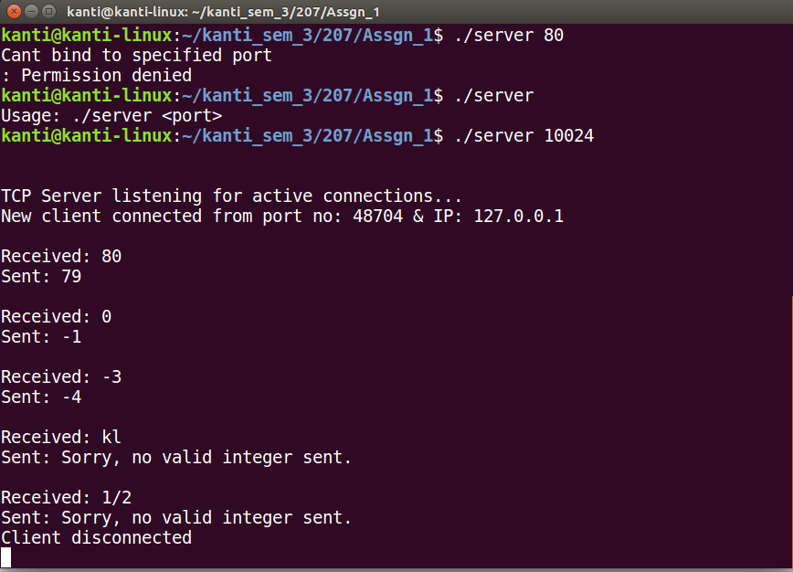

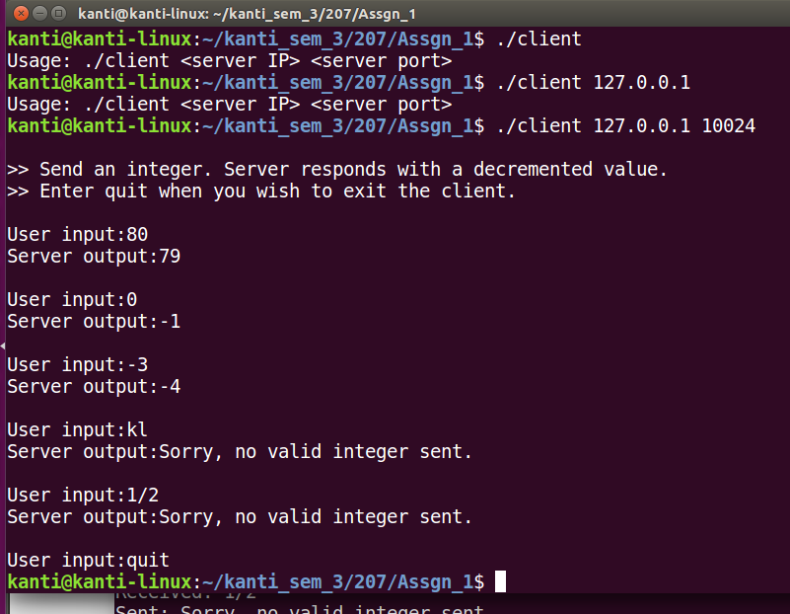

References:

1. Internetworking with TCP/IP Vol. 3, Client-Server programming and applications, Comer and Stevens, Linux/POSIX Sockets version, ISBN: 0-13-032071-4, 2001